Obtaining individual payroll information for specific departments
This query should be ran monthly.

- In self-service, click on the Finance Tab.
- Click on Budget Queries
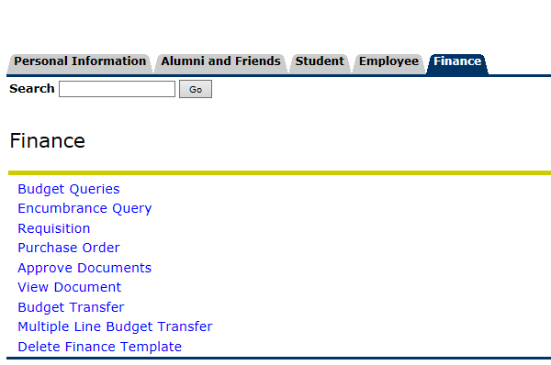

- Click on Payroll Expense Detail, then Create Query. 3a. If you want to save the query so you don’t have to enter the information again, name the query and the basic information is saved. It will give you fiscal year to date information, but you can sort it by period.
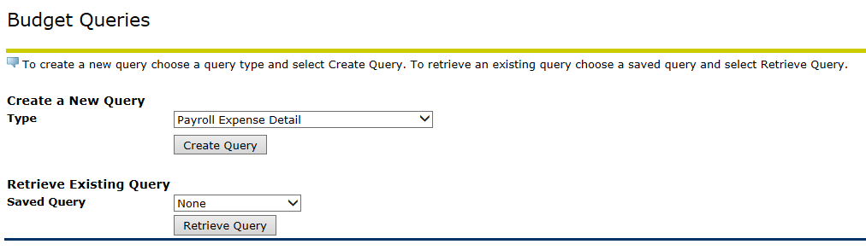
Fiscal Year Periods

1 = July | 2 = August
3 = September | 4 = October
5 = November | 6 = December
7 = January | 8 = February
9 = March | 10 = April
11 = May | 12 = June
14 = Entire fiscal year (Including accrual period)

If you don’t want to pull benefits into the query, you can put “61%” in the Account block and it will just pull salaries that are paid. If you want to pull a series of Orgs with the same 3 beginning numbers, you can do that as well. For example, 224% in the org field will give you all the different orgs that you have access to in one query. (If for some reason you are not getting any information, be sure that the “Account Type” field is blank.)
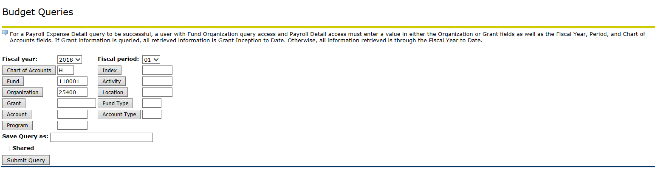

3a. Retrieving a saved query.
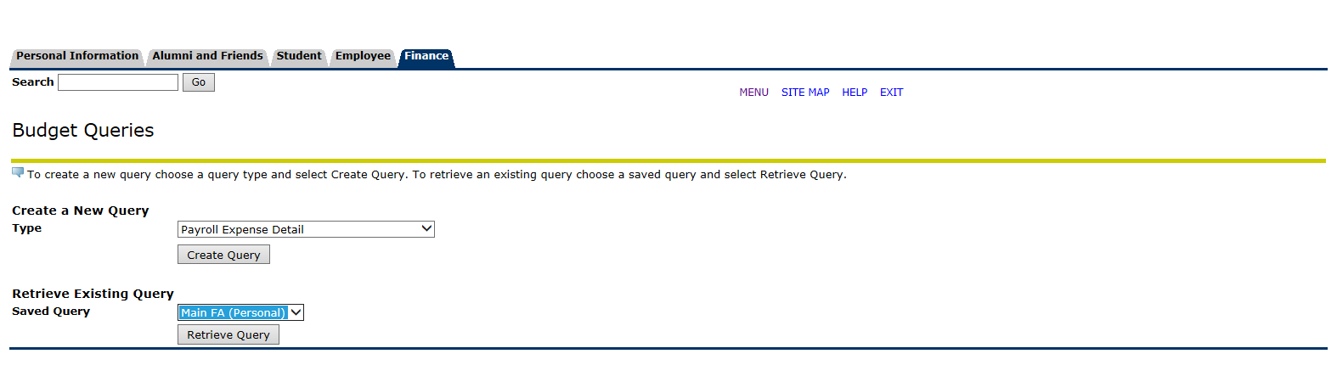

- Once you retrieve your desired information, at the bottom left, you can click on “Download All Columns” and it will pull the information into Excel. It will include both salary and benefit expenses if you leave the account code blank. If you find any discrepancies, please let the payroll office know so that corrections can be made.

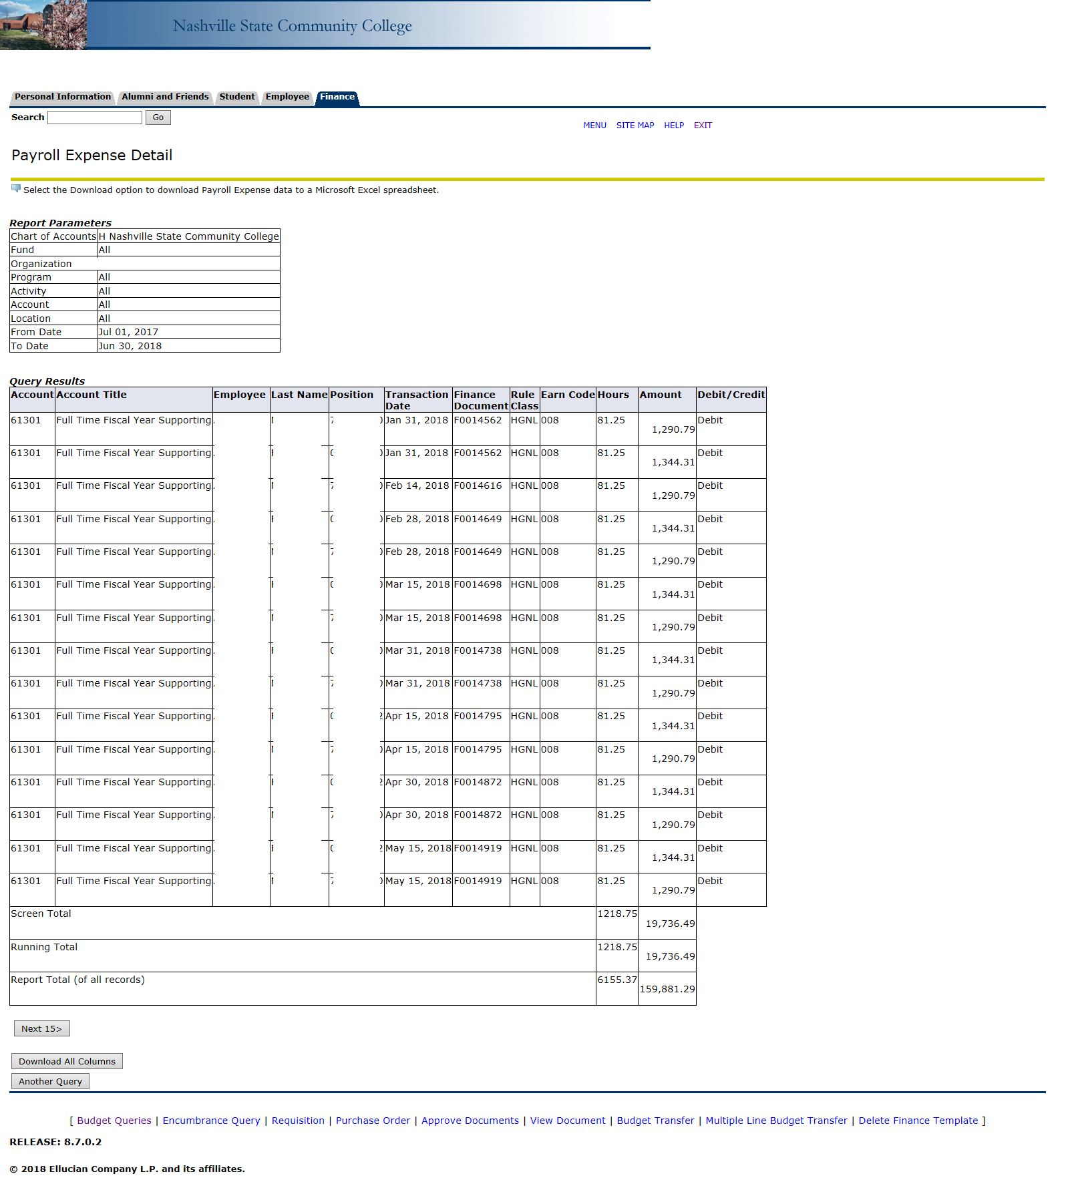
If have problems retrieving information or retrieving your department, please contact the payroll department. You can email Becky.Abuorf@nscc.edu or Deanna.Jackson@nscc.edu.

